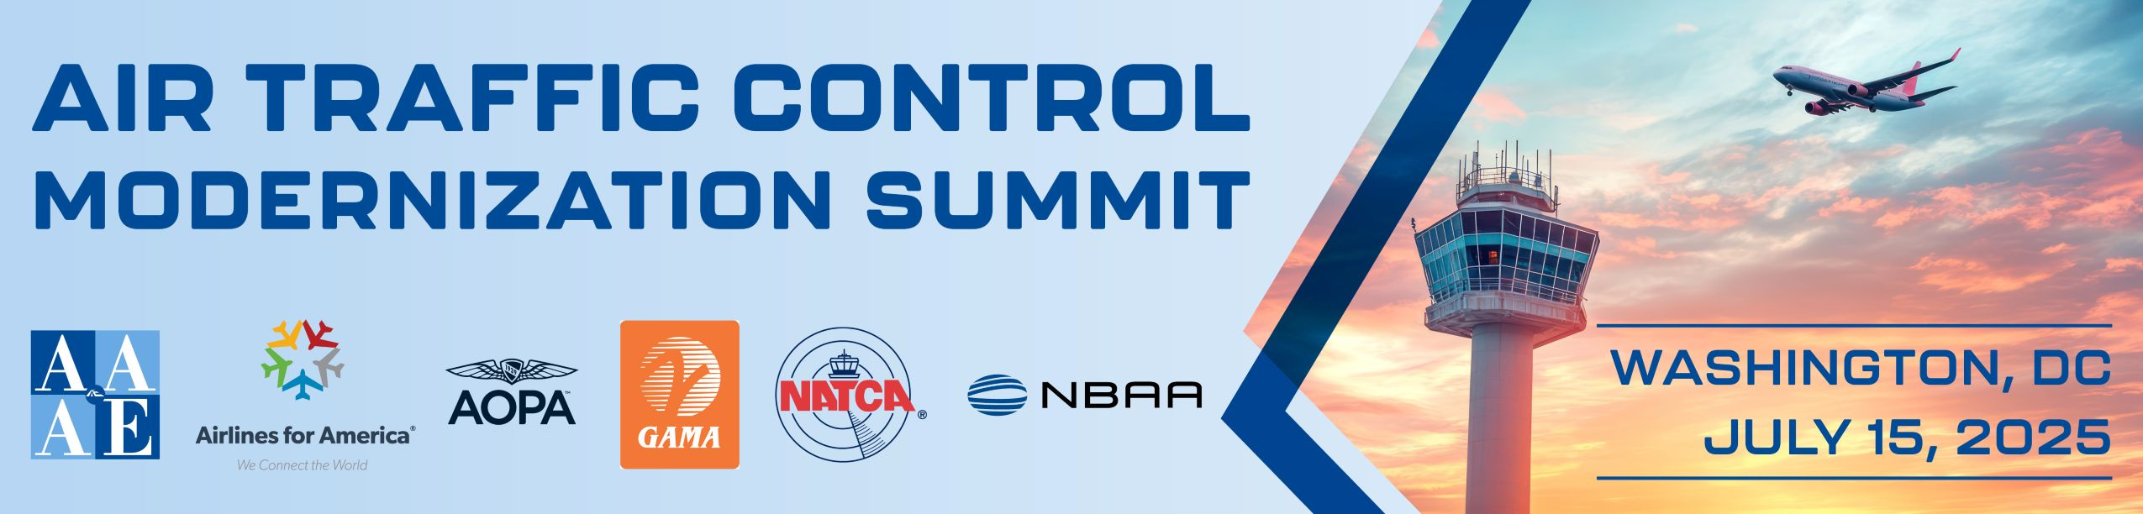

Air Traffic Control Modernization Summit – July 15, 2025
Host Sponsors: AAAE, A4A, AOPA, NATCA, GAMA and NBAA
Hilton Washington DC-Capitol Hill

8 – 9am Registration
9 – 10 am The Case for ATC Modernization: A Discussion with Industry Leaders
Industry leaders’ discussion of the current limitations and future potential of the U.S. Air Traffic Control (ATC) system. Representing a cross-section of the aviation ecosystem—airlines, air traffic controllers, general aviation, manufacturers and airport operators—these experts will share insights into the challenges impacting the safety, efficiency, and scalability of our national airspace. The discussion will also look ahead, focusing on how targeted investments, modernization, and public-private collaboration can yield significant benefits.
10 – 10:30 am Break
10:30 – 10:45 am View from the Hill with Chairman Ted Cruz (R-TX)
10:45 – 11 am View from the Hill with Rep. Steve Womack (R-AR)
11 – 12 pm Air Traffic Control Modernization: Operator Experiences and Opportunities
This panel brings together operators from across the aviation industry to share their firsthand experiences navigating the current Air Traffic Control (ATC) system and to provide insights into modernization efforts. Panelists will discuss the day-to-day challenges they face under the existing system, including operational inefficiencies, capacity constraints, and the impact on customer service and scheduling. The conversation will also explore what’s possible when advanced technologies, improved procedures, and integrated systems are implemented. Panelists will highlight the benefits of an upgraded system—such as increased safety, enhanced efficiency, reduced delays, and better overall experience for passengers, pilots, and all system users.
12 – 1:15 pm Lunch

1:15 – 2:15 pm Delivering the Future ATC System: On Time, On Budget, and with Accountability
The next era of air traffic modernization will redefine how complex systems are managed and delivered. For the first time, a single prime contractor is expected to take the lead on the end-to-end design, construction, and modernization of the National Airspace System, marking a major departure from the FAA’s traditional approach to infrastructure and systems procurement. This model has important implications for industry, oversight, timelines, and accountability. Leaders from across the aviation and infrastructure sectors will explore what this new strategy means in practice and how it differs from past processes. From radar and automation platforms to communications systems and facility construction, panelists will discuss how this integrated approach can streamline delivery, improve system interoperability, and accelerate progress. They’ll also address key questions around governance, risk management, and how success will be defined and measured.
2:15 – 2:45 pm View from the Hill with Rep. Rick Larsen (D-WA)
2:45 – 3:15 pm Break
3:15 – 4:15 pm Modernizing Air Traffic Control: Key Technologies for Transformation in the Sky and on the Ground
This panel examines the critical technologies that will be part of the new air traffic control system —both in the sky and on the ground, including advanced surveillance systems, communications, automation platforms, avionics upgrades, and more. Panelists will discuss the comprehensive range of innovations reshaping airspace and airfield management. The session addresses specific technologies enabling this transformation, comparing them to legacy systems, and evaluating their operational benefits for controllers, pilots, airports, and passengers and will highlight how modernization will enhance safety, efficiency, coordination, and capacity at airports and across the National Airspace System.
4:15 – 4:45 pm Fireside Chat with Sen. Tammy Duckworth (D-IL)
4:45 – 5:30 pm The Runway Ahead: Next Steps for Congress, Administration and Aviation Stakeholders
Following the day’s discussion of current challenges, proposed solutions, and the necessary next steps to ensure the advancement of a fully modernized air traffic control system, this panel will focus on maintaining momentum within Congress, the Department of Transportation, and among system users and stakeholders, while also identifying key opportunities and addressing potential risks that could influence the successful implementation of this transformative initiative.
5:30 – 6:30 pm Reception
6:30 pm End

